Food Share

**Final Project Report**

Smartphone Based development

**Professor: Ahmed Rabah**

**-By Prateek Arora**

**Project storyboard:**

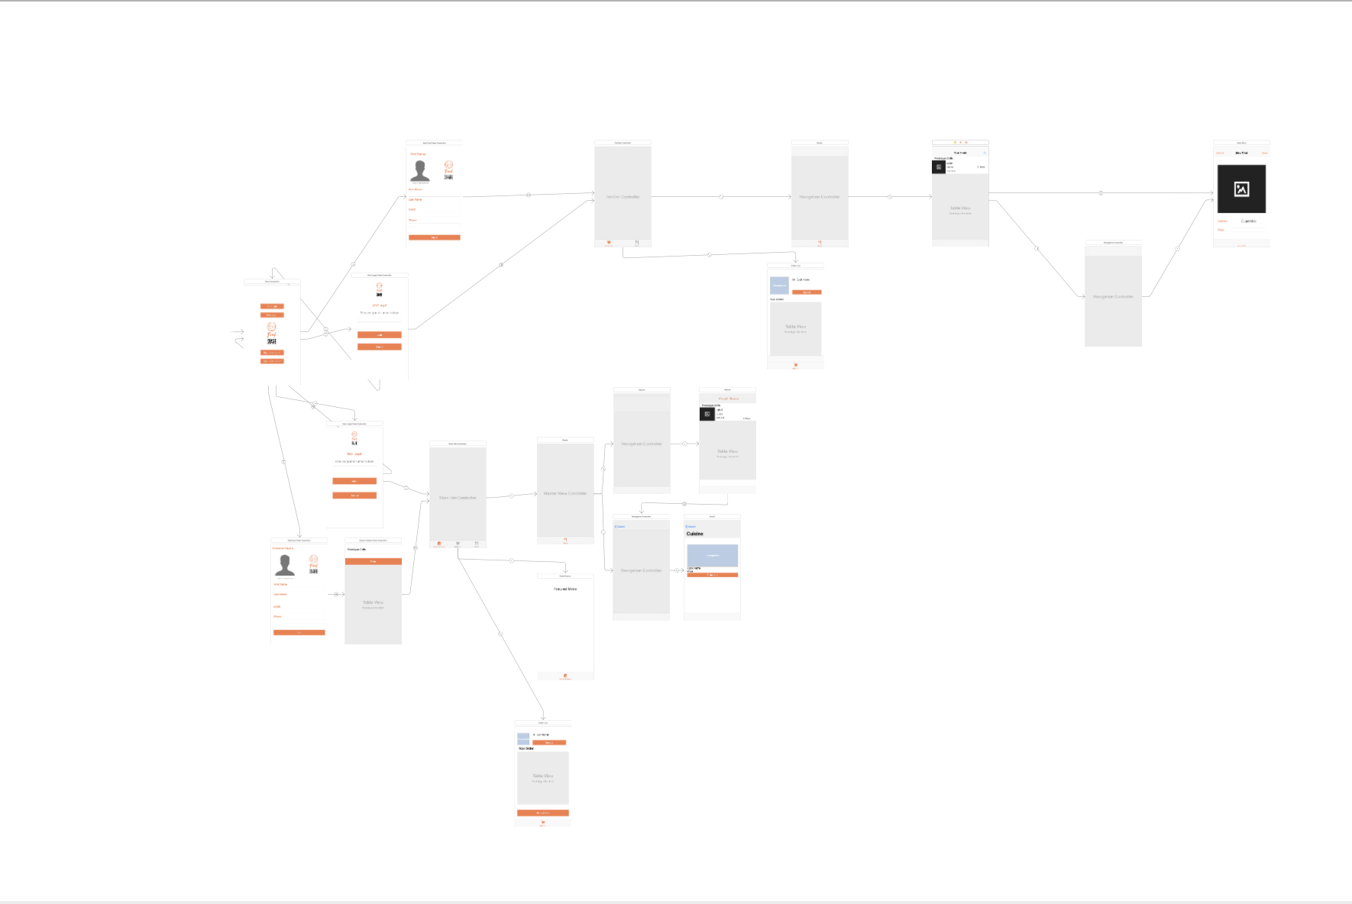

**Project code structure:**

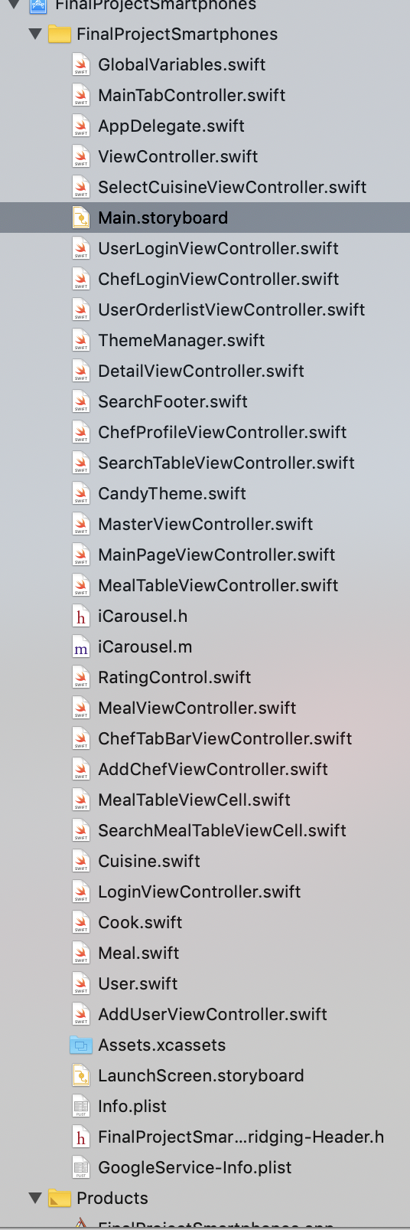

This project has of two types of user flows:

1. Customer flow
2. Cook flow

Customer Flow:

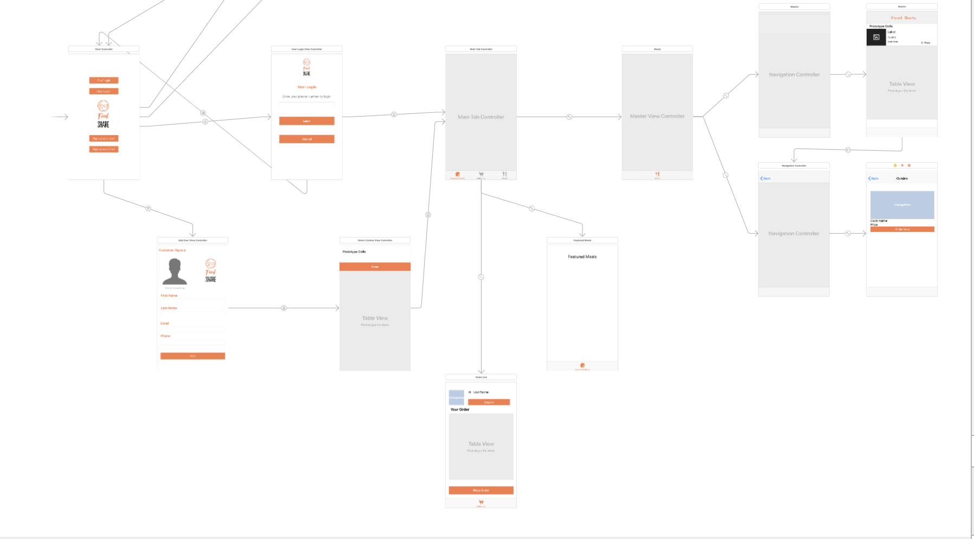

* User starts on Homepage and signup/logs in
* After logging in user will discover trending meals
* From meal list page, he can search for his preferred meal and order it
* From the order list page the user checks out and completes the purchase

**Home Page:**

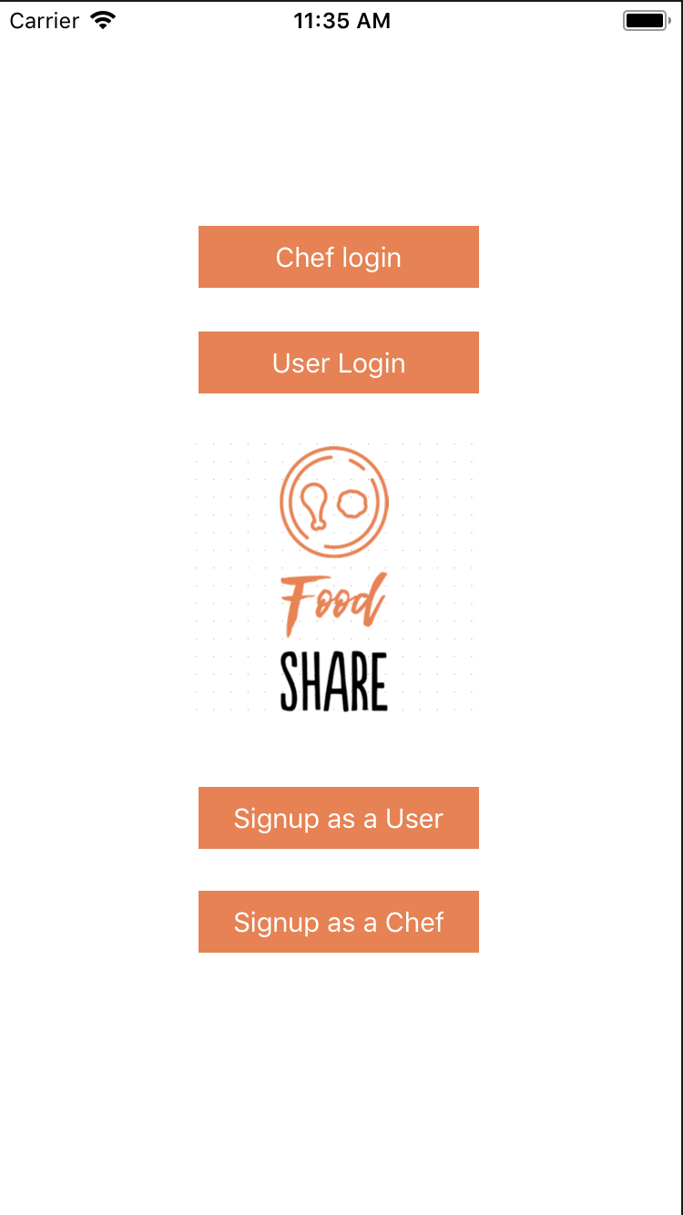

**Customer Signup**

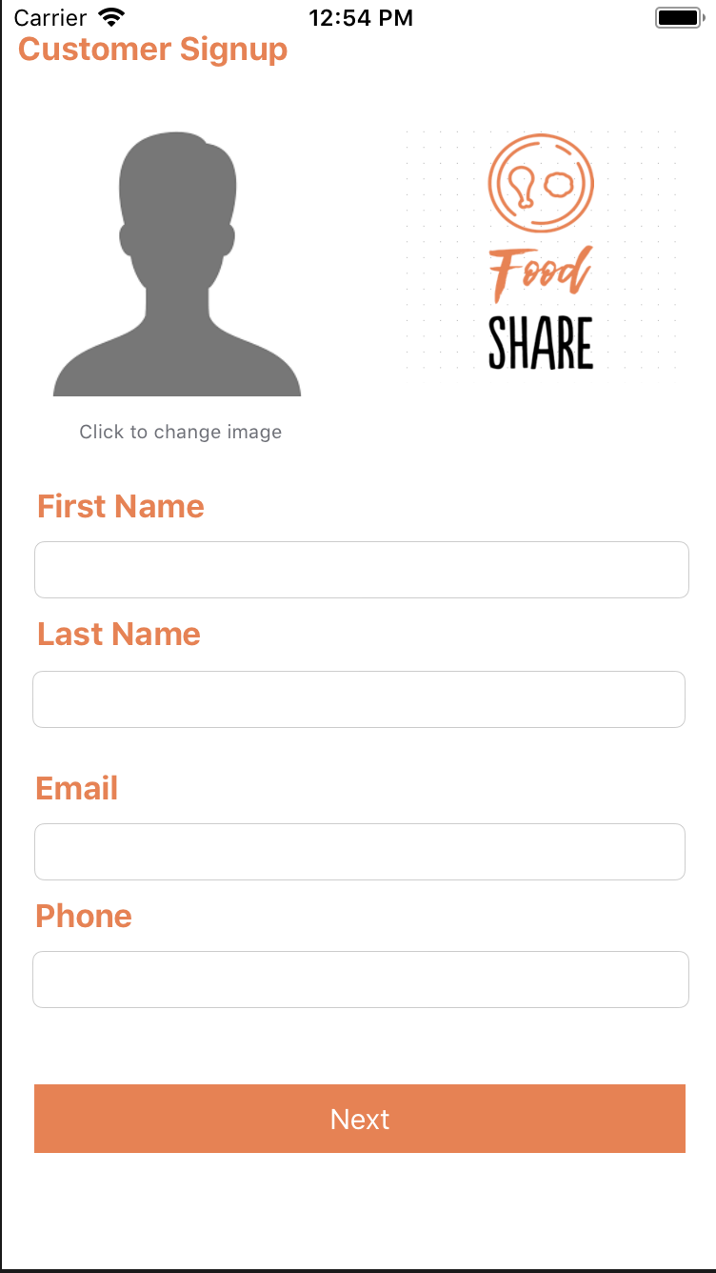

**Multiselect view for cuisines**

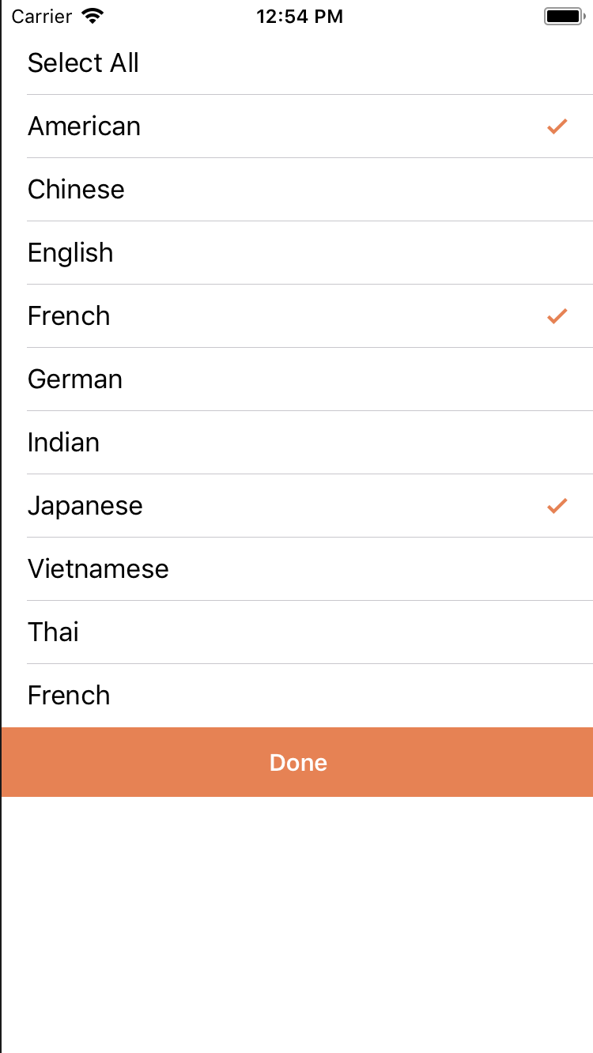

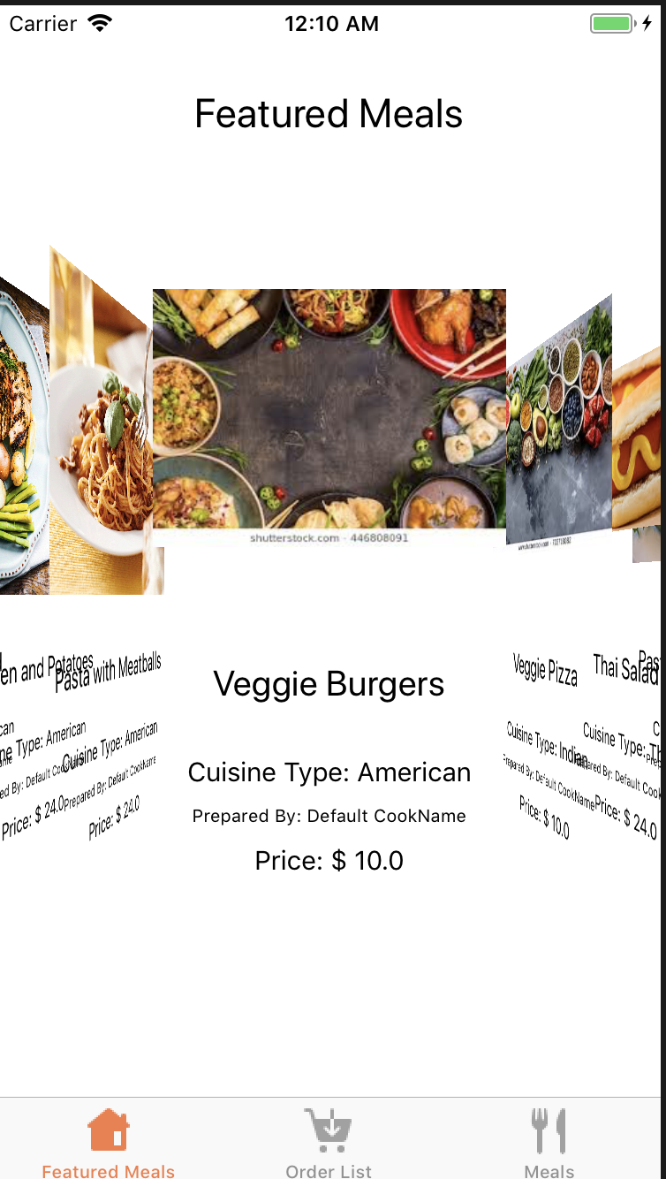

Featured Meals are displayed to the customer in a fancy carousel view

The entire meal list from all the chefs are displayed to the customer in a very user friendly cuisine based search as displayed below:

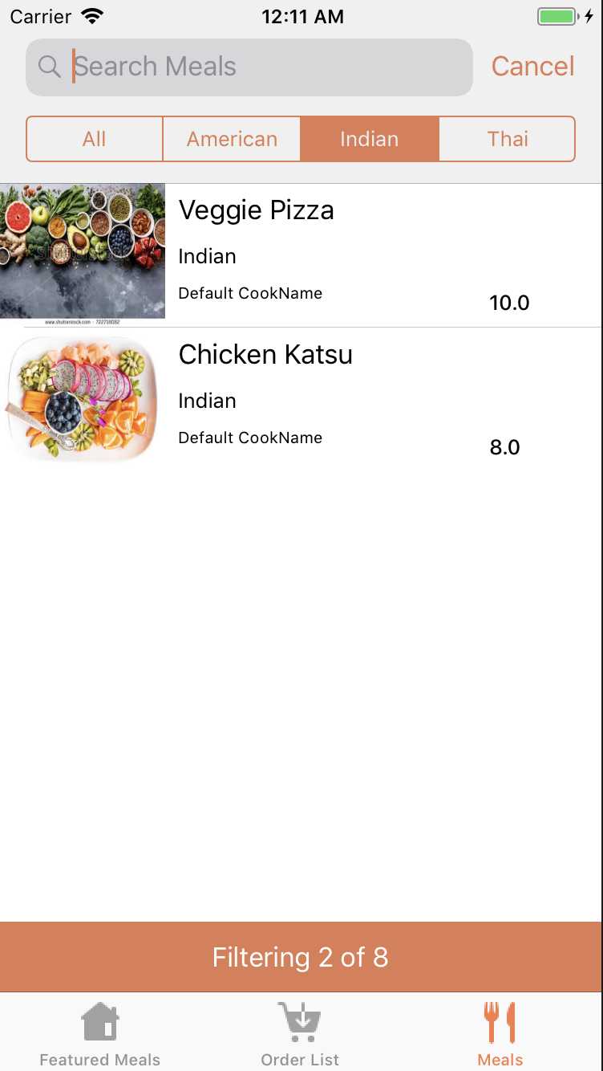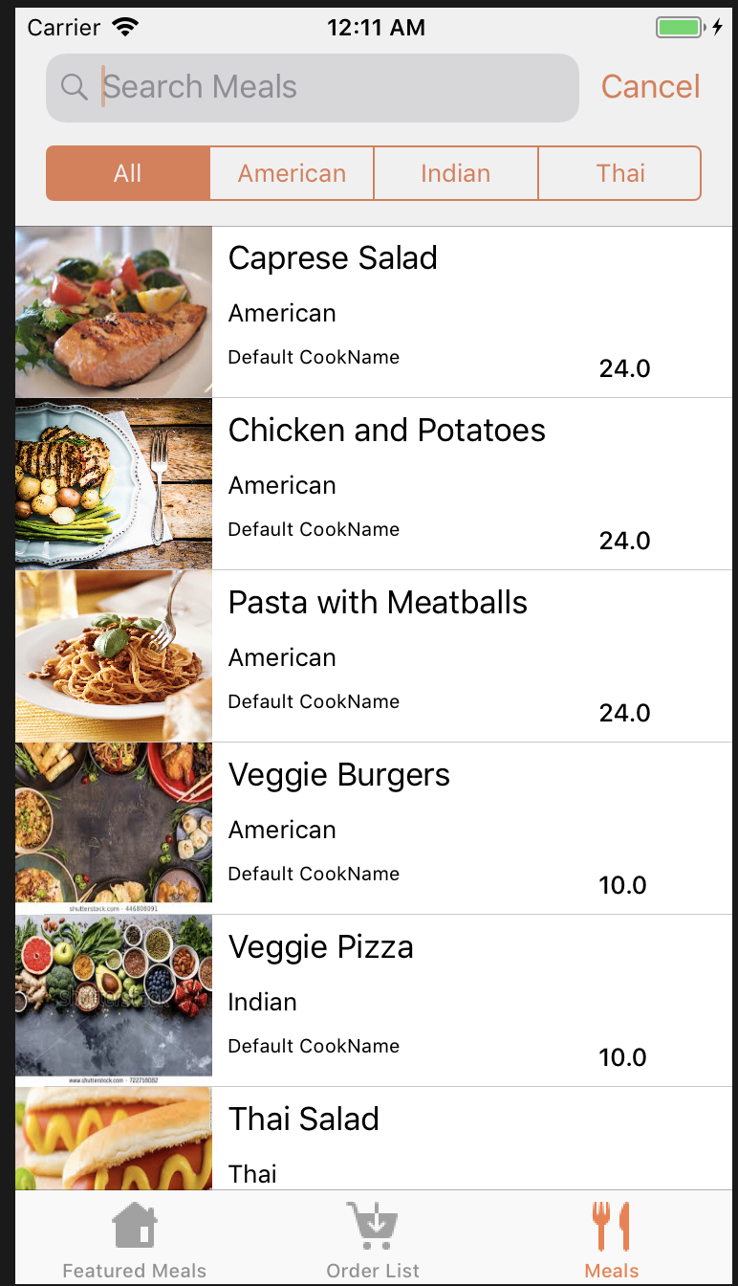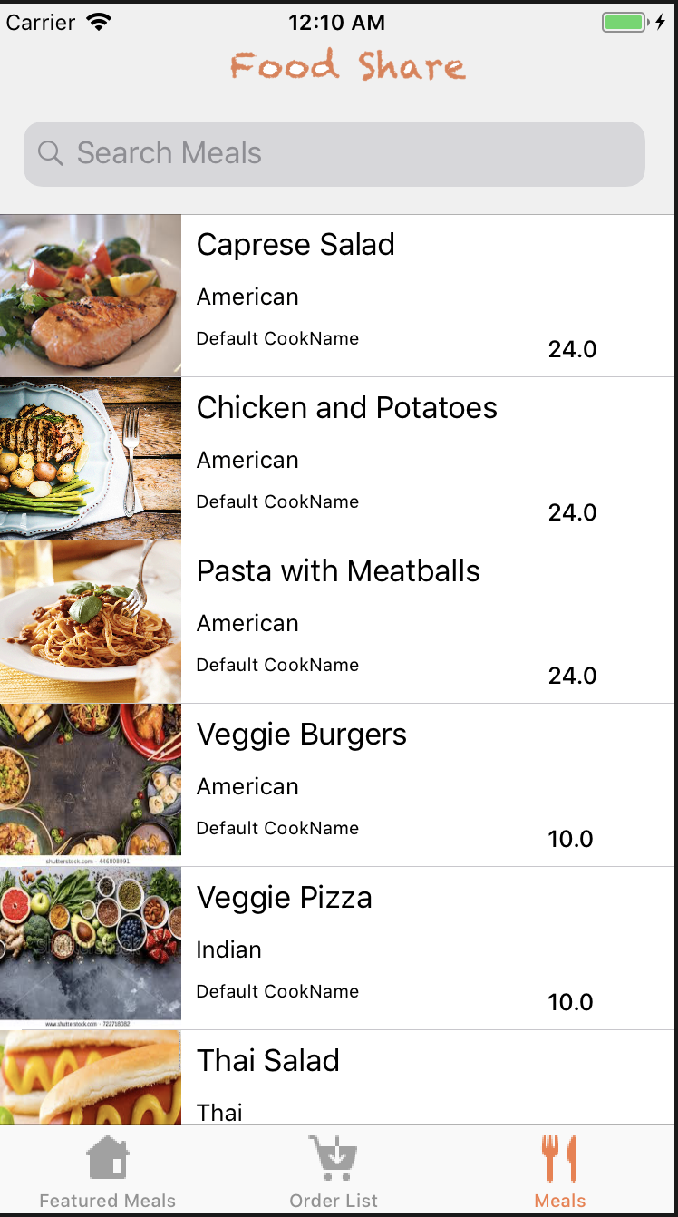

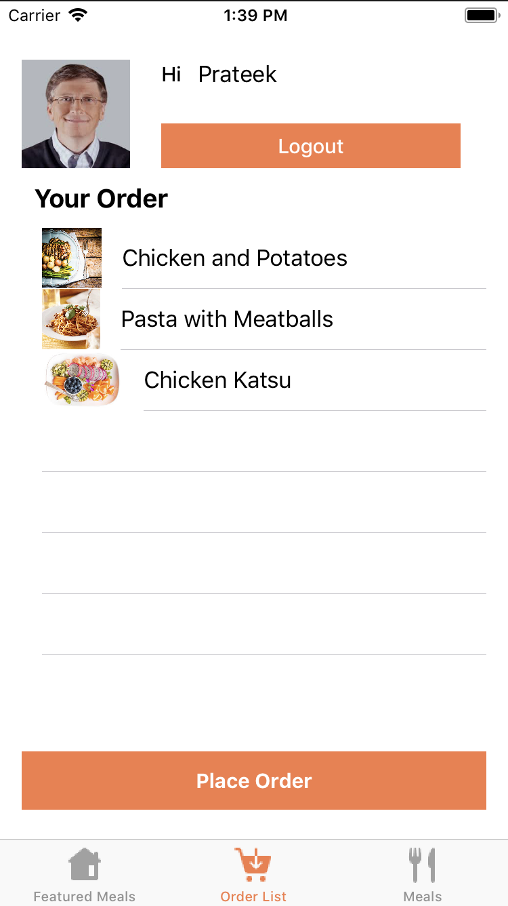 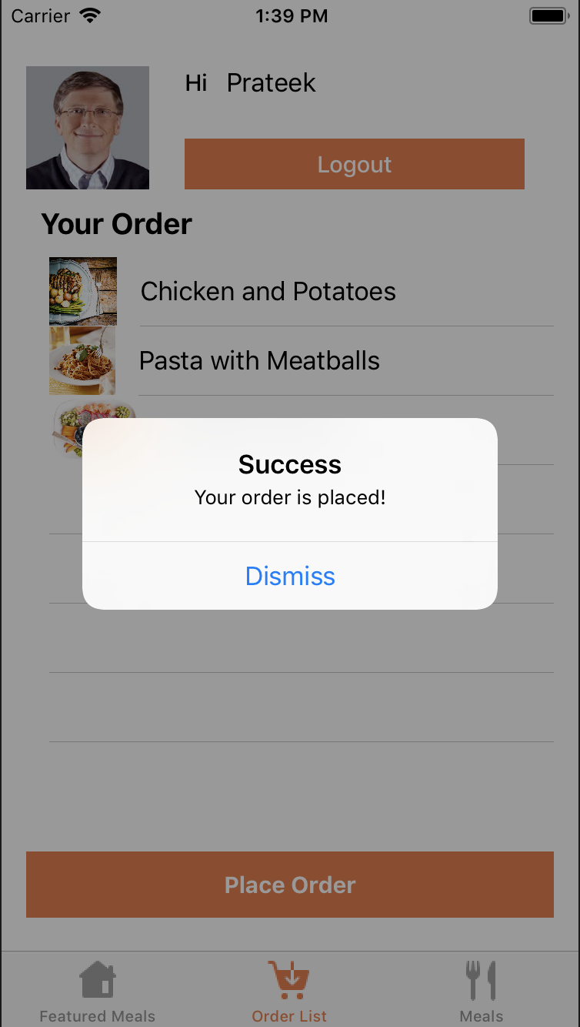

The meals selected by the customer are then added to the order list where the order can be edited before being placed by the customer. Once the order is placed by the customer, the customer and the respective chefs are notified of the order placed.

Chef flow:

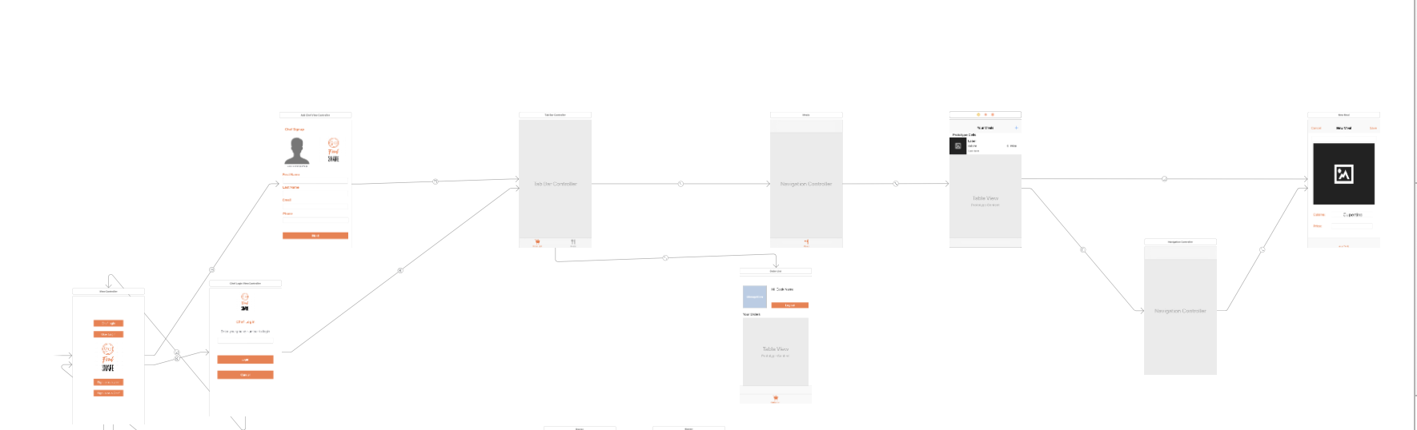

* Chef starts on homepage and signs up/ logs in
* After logging in the chef will be able to look at this profile/past orders
* Chef can edit his meal recipes and photos
* Chef can access his current order list and see who has ordered his food

Home page:



Chef Signup Page

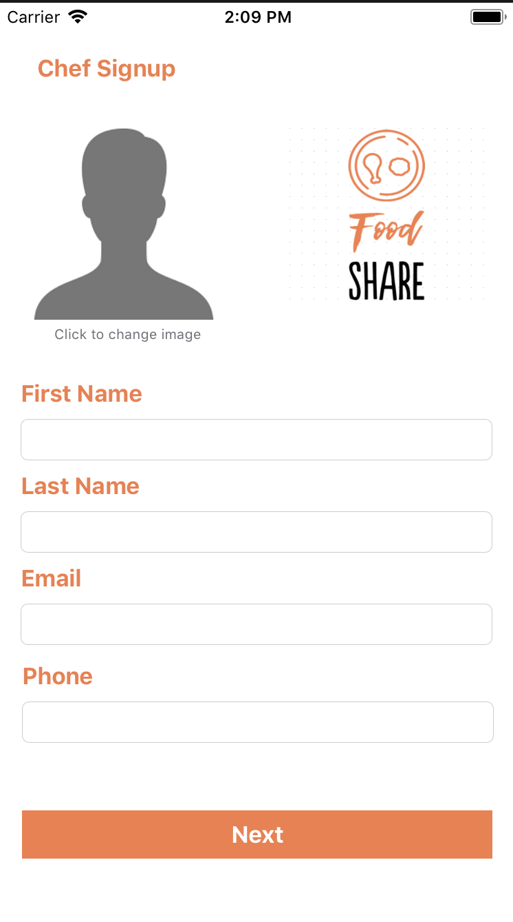

Chef Profile/ Order list page

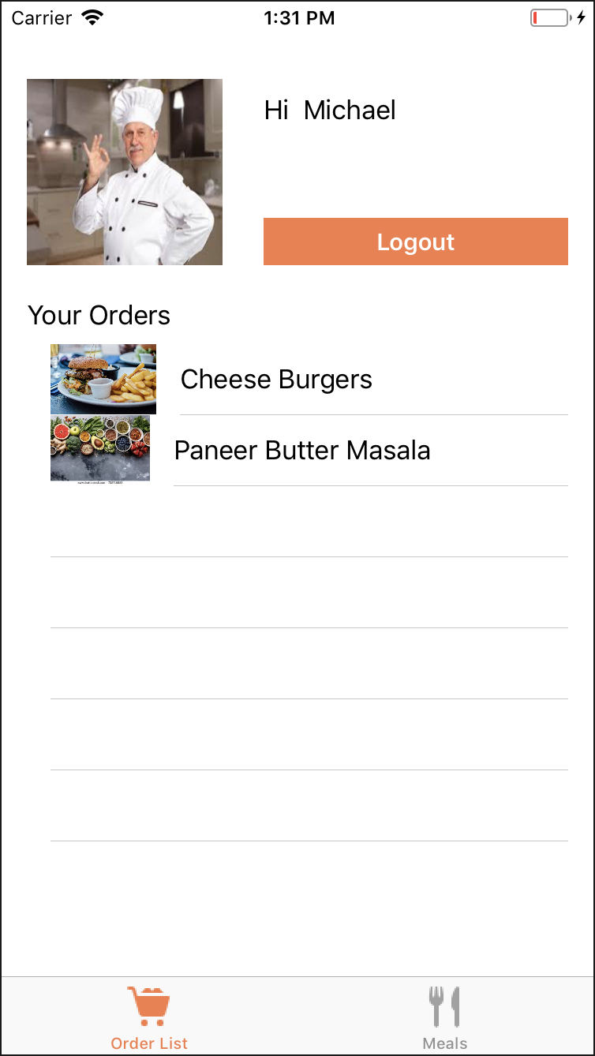

Chef meal list page

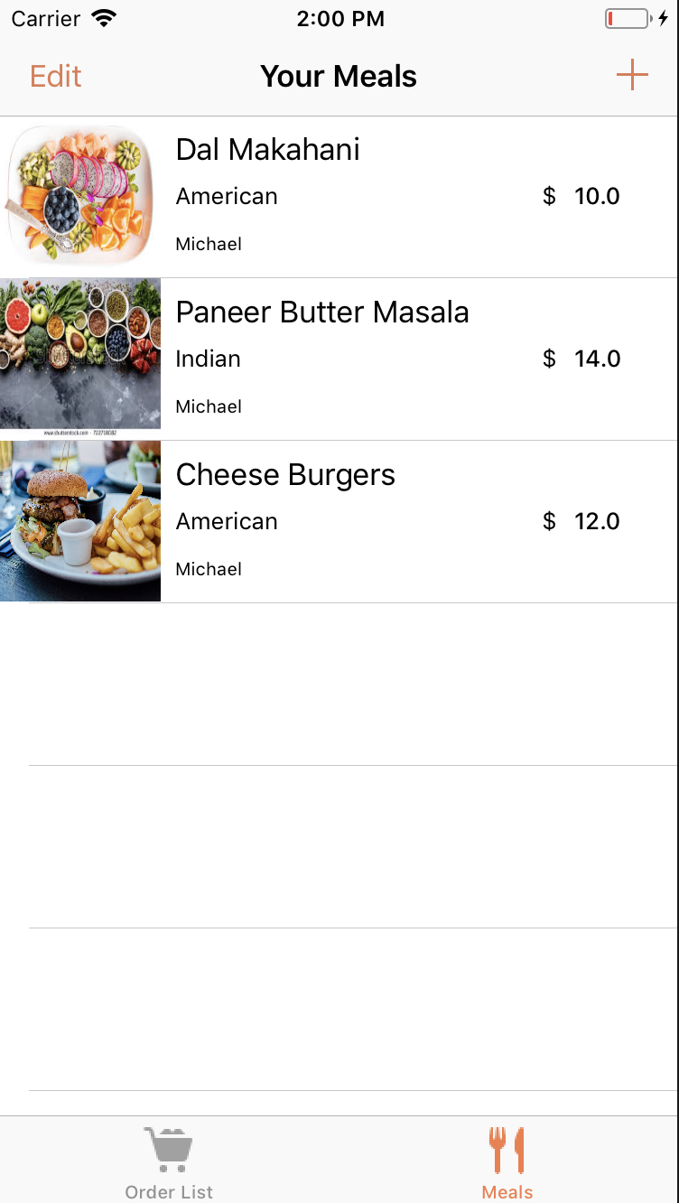

Add meal page for chef

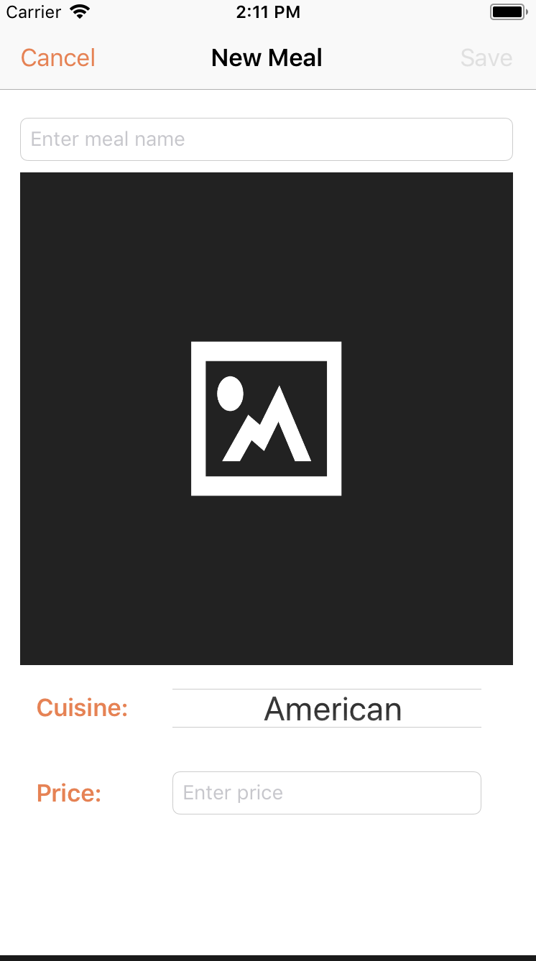

the chef can add the meals he wants to sell in the meal list page and can see all the orders placed by the customers in his profile page from where he can contact the customers who’ve ordered his food.

**Technical Specs:**

**Development Process:** Swift is used to develop this project using Xcode v9.2 . Most of the development is done using storyboard and segues along with few pages which are programmatically developed (SelectCuisineController and Carousel View for the customer side)

**Libraries Used:** iCarousel (used for the carousel view for the featured meals on the customer side)

**Server Used:** Google Firebase

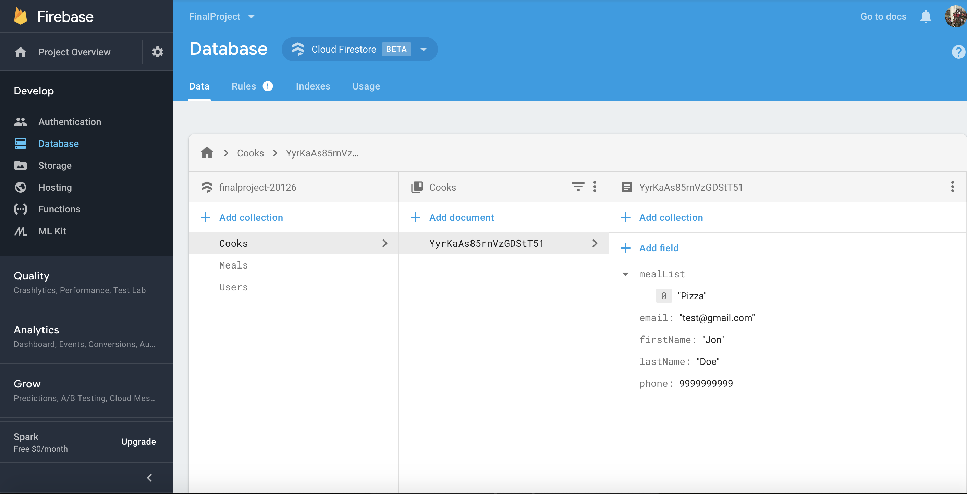

The database server consists of 3 collections

1. Meals
2. Users
3. Cooks

**Data Model:**

